SUBMISSION IN RESPONSE TO SHOW CAUSE NOTICE ISSUED IN FORM GST-RFD-08

Date: - .../.../202...

To,
Deputy Commissioner of State Tax,
..................................................
..................................................
..................................................

Subject: Submission in response to Show Cause Notice issued in FORM GST-RFD-08 for the period April 202.. to December 202.. in case of .........................................., Address: - ....................................................................................................
Ref.: SCN Dated .../.../202.. vide reference number .................................

GSTIN: - .............................................

Sir/Madam,

With reference to the above stated show cause notice, on behalf of my above stated client, I would like to submit pointwise reply as under
1. As you are dealing with multi HSN commodity. Kindly produce HSN wise and rate of tax wise outward supply detail.
Reply: The HSN wise and rate of tax wise outward supply for the period 01.04.202... to 31.12.202.... is enclosed herewith.

2. Detail process chart of business entity.
Reply: Production procedures:
The Finished Goods would be produced generally in 10 days.
How the Production done is described as under by flow charts

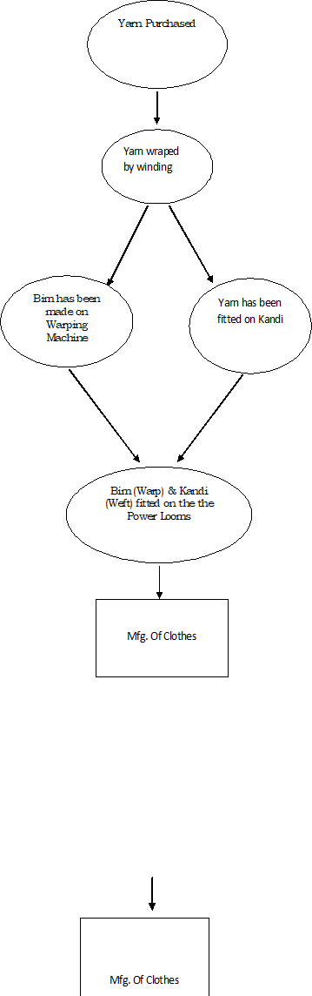

3. Further discrepancies were observed in input tax credit shown in GSTR-3B of Rs.37,23,926/- while Annexure-B shown Rs.40,63,853/-. Kindly produce reconciliation of the same, for computation of refund lower value will be considered.
Reply: The Detail related Input tax credit shown in GSTR-3B, Annexure-B and reconciliation statement are as follows:
• Input tax credit shown in GSTR-3B
Eligible ITC | As per GSTR-3B |  |  | Total
Period | IGST | CGST | SGST
April | 0.00 | 270287.00 | 270287.00 | 540574.00
May | 0.00 | 23541.00 | 23541.00 | 47082.00
June | 0.00 | 189178.22 | 189178.22 | 378356.44
July | 0.00 | 359739.87 | 359739.87 | 719479.74
August | 0.00 | 398782.64 | 398782.64 | 797565.28
September | 699.50 | 276429.00 | 276429.00 | 553557.50
October | 0.00 | 267897.00 | 267897.00 | 535794.00
November | 0.00 | 122020.00 | 122020.00 | 244040.00
December | 17982.00 | 115309.00 | 115309.00 | 248600.00
Total | 18681.50 | 2023183.73 | 2023183.73 | 4065048.96

• Input tax credit Shown in Annexure-B
Eligible ITC | As per Annexure-B |  |  | Total
Period | IGST | CGST | SGST
Apr To Dec-2023 | 18681.50 | 2022586.00 | 2022586.00 | 4063853.50
Total | 18681.50 | 2022586.00 | 2022586.00 | 4063853.50

• Reconciliation of ITC between GSTR-3B and Annexure- B
Sr. No | ITC | IGST | CGST | SGST | Total
1. | As per GSTR-3B | 18681.50 | 2023183.73 | 2023183.73 | 4065048.96
2. | As per Annexure-B | 18681.50 | 2022586.00 | 2022586.00 | 4063853.50
3. | Difference  (1-2) | Nil | 597.73 | 597.73 | 1195.00
The Ld. Deputy Commissioner contended that the credit was claimed in GSTR-3B is Rs.37,23,926 which is totally wrong. The actual ITC was claimed in GSTR-3B is Rs. 4065048.96, for computation of refund taxpayer consider the correct value (lower value between GSTR-3B & Annexure B).

4. Kindly produce inverted and non-inverted inward and outward supply separately.
Reply:
• Inverted and non-inverted outward supply
Inverted outward supply | HSN Code | Rate | Taxable Value | CGST | SGST | IGST
Sale of Grey Cloth | 540710 | 5% | 57605529 | 1252124 | 1252124 | 376056
Job work income on same cloth | 9988 | 5% | 91730 | 2105 | 2105 | 376

Non-inverted outward supply | HSN Code | Rate | Taxable Value | CGST | SGST | IGST
Nil

• Inverted and non-inverted inward supply
Inverted Inward supply | Rate | Taxable Value | CGST | SGST | IGST
Purchase of Yarn | 12%,18% | 32572841 | 2016268 | 2016268 | 0

Non inverted Inward supply | Rate | Taxable Value | CGST | SGST | IGST
Purchase other than Yarn | 5% | 626343 | 6317 | 6317 | 18681

5. Kindly produce sample invoice
Reply: The copy of invoice of H D Retails having GSTIN .......................................... Dated: ...../...../202.... with Taxable value of Rs.1,37,294.45 is enclosed. Refund is not eligible on this invoice.

I hereby specify that all the contents of this reply are true and valid to the best of my knowledge and belief.
Kindly consider the same and oblige.

Thanking you.

Yours faithfully,
Legal Name: - .............................. (...........................)

Encl.:
• The HSN wise and rate of tax wise outward supply
• Copy of invoice of H D Retails

